**SuperLap Racing Line Optimization System**

**EPI-USE**

**Quintessential**

Amber Ann Werner [u21457752]

Milan Kruger [u04948123]

Qwinton Knocklein [u21669849]

Sean van der Merwe [u22583387]

Simon van der Merwe [u04576617]



Contents

Introduction 1

User Characteristics 2

User Stories 4

Service Contracts 7

Track Image Processing 7

Racing Line Optimization 7

AI Training Service 7

Visualization Service 7

User Account Management *(optional)* 8

Lap Time Comparison 8

Requirements 9

Functional Requirements 9

Architectural Requirements 11

Architectural Design Strategy 11

Architectural Strategies 12

Architectural Quality Requirements 13

Architectural Design and Pattern 15

Architectural Constraints 17

Technology Choices 17

Diagrams and Models 24

Architecture Diagram 24

Class Diagram 25

Domain Model 26

Deployment Model 27

Live Deployment System 28

Use Case Diagrams 29

Manuals 30

Installation Manual 30

Technical Installation Manual 31

User Manual 32

System Requirements 32

Step-by-Step Workflow 32

Troubleshooting 35

Contact or Support Info 35

Specifications and Standards 36

Machine Learning Specification 36

API Documentation 37

Coding Standards 38

Naming Conventions 38

File and Folder Structure 38

Formatting Standards 39

Coding Practices 40

Version Control Guidelines 40

Tools and Configurations 41

Language/ Framework-Specific Conventions 41

Testing Policy 42

Testing Scope & Levels 42

Testing Types & Frequency 42

Entry & Exit Criteria 42

Contribution of Teammates 45

Project Manager 45

Amber Werner 45

Backend Developers 45

Qwinton Knocklein 45

Sean van der Merwe 45

Front End Developers 45

Simon van der Merwe 45

Milan Kruger 46

Appendix: Old Versions of SRS iv

Version 1 [26/05/2025] iv

Version 2 [26/05/2025] xxxix

# Introduction

There is a growing need for accessible, data-driven training tools in motorsports, especially among students, amateur riders, and enthusiasts who lack access to expensive telemetry systems or real-world testing environments. SuperLap Racing Line Optimization System addresses this need by providing an AI-powered platform that helps superbike riders identify the fastest possible racing line on a racetrack.

The project aims to develop a Reinforcement Learning and Computer Vision-based system that analyses a top-down image of a racetrack, simulates thousands of optimal pathing scenarios, and overlays the ideal racing line on the map. Designed with usability and precision in mind, SuperLap focuses on delivering accurate, performance-enhancing insights in a visually intuitive format, supporting smarter race training without the traditional barriers of cost or access.

## User Characteristics

#### Amateur & Hobbyist Racers

**Characteristics:**

* **Skill Level:** Novice to intermediate riders.
* **Goals:** Improve lap times, learn optimal racing lines, understand basic track dynamics.
* **Technical Proficiency:** Basic; comfortable using apps but limited technical knowledge.
* **Usage:**
  + Upload 2D track images from local circuits.
  + Use AI-generated racing lines as visual training aids.
  + Compare different racing lines for self-improvement.
* **Motivation:** Affordable alternative to professional coaching and telemetry systems.

**Example:** A track-day rider at Kyalami Circuit aiming to shave seconds off lap times.

#### Motorsport Coaches & Instructors

**Characteristics:**

* **Skill Level:** Advanced (former or current racers).
* **Goals:** Teach optimal racing strategies using AI-generated insights.
* **Technical Proficiency:** Moderate; knowledgeable in racing physics, less so in AI/ML.
* **Usage:**
  + Validate AI-generated racing lines against personal experience.
  + Generate annotated visual materials for student feedback.
  + Compare multiple rider lines for debriefing sessions.
* **Motivation:** Enhance coaching efficiency with data-backed tools.

**Example:** A racing school instructor using the system to highlight braking points to students.

#### Sim Racing Enthusiasts

**Characteristics:**

* **Skill Level:** Varies from casual to competitive sim racers.
* **Goals:** Optimize virtual race performance in games like Assetto Corsa or Gran Turismo.
* **Technical Proficiency:** High; comfortable with mods, data analysis, and telemetry tools.
* **Usage:**
  + Import in-game 2D track maps for AI analysis.
  + Compare AI-generated lines against in-game telemetry data.
  + Share optimized lines with online sim racing communities.
* **Motivation:** Gain a competitive edge in online and league racing.

**Example:** An iRacing league competitor seeking the ideal Monza racing line.

#### Professional Racing Teams (Small/Privateer)

**Characteristics:**

* **Skill Level:** Expert (professional riders, engineers).
* **Goals:** Fine-tune bike setup and validate racing strategies.
* **Technical Proficiency:** High; familiar with AI, telemetry, and vehicle dynamics.
* **Usage:**
  + Cross-reference AI predictions with real telemetry data where available.
  + Test hypothetical scenarios (e.g: wet vs dry racing lines).
  + Integrate with existing telemetry tools via API if supported.
* **Motivation:** Cost-effective supplement to expensive motorsport analytics solutions.

**Example:** A privateer Moto3 team optimizing cornering lines with limited budget.

#### Engineering & Motorsport Students

**Characteristics:**

* **Skill Level:** Academic learners in racing dynamics and AI.
* **Goals:** Study racing line theory, reinforcement learning applications, and vehicle physics.
* **Technical Proficiency:** Medium; some coding and mathematical background.
* **Usage:**
  + Experiment with different AI models (e.g: DQN, PPO).
  + Validate theoretical models against system simulations.
  + Use 2D track data as accessible inputs for research projects.
* **Motivation:** Research, thesis projects, and hands-on learning.

**Example:** Mechanical engineering student analysing Suzuka's "S-curves" for a thesis.

### User Stories

#### Core User Stories (Functionality & User Experience)

1. As a rider, I want to upload a top-down 2D image of my racetrack so the system can analyse it for optimal racing line suggestions.
2. As a user, I want to view and customize the uploaded image (zoom, pan, annotate) to better understand the data.
3. As a user, I want to see the AI-generated optimal racing line overlaid on the track to compare it with my own strategy.
4. As a motorsport enthusiast, I want the system to simulate multiple racing lines using reinforcement learning so I can evaluate their performance under different conditions.
5. As a rider, I want to compare my recorded lap times with AI-predicted optimal lap times to identify areas for improvement.
6. As a beginner racer, I want simple, actionable guidance (e.g: “brake here,” “turn in here”) based on the AI racing line to apply during real-world riding.
7. As a user, I want to toggle between different visualization modes (e.g: 2D top-down view) to analyse racing lines effectively.

#### Visualization & Comparison Stories

1. As a racer, I want to switch between user-set and AI-optimized racing lines to choose the best fit for my skill level.
2. As a user, I want to scrub through the lap simulation to analyse critical points like braking zones and apexes.
3. As a coach, I want to export AI-generated racing lines and performance data for offline review and training.

#### Interface & User Experience Stories

1. As a casual user, I want a guided tutorial on how to interpret AI racing lines and use the app effectively.
2. As a user, I want to switch between light and dark modes for better visibility depending on the time of day.

#### Backend & Performance Stories

1. As a backend developer, I want the system to efficiently process large track images to reduce wait time for the user.
2. As a power user, I want to configure AI training parameters (e.g: epsilon decay, learning rate) for custom experiments.
3. As a team, we want to store training sessions and model states securely in a database so that progress isn’t lost between runs.

#### Gamification & Community Stories

1. As a user, I want to share my best lap and AI-optimized strategy with others to compare and compete.
2. As a community member, I want to vote on or comment on AI racing lines that others have shared to collaborate and learn.
3. As a racer, I want leaderboards showing AI lap times vs. user lap times to motivate improvement.

## Service Contracts

### Track Image Processing

|  |  |
| --- | --- |
| Aspect | Description |
| Service Name | Track Image Processing |
| Description | Allows users to upload a top-down image of a racetrack. The system processes and standardizes it for analysis. |
| Inputs | Image file (JPG/PNG), optional track name or location |
| Outputs | Normalized track layout data (internal format), confirmation message |
| Interaction | Frontend sends image via HTTP POST; backend responds with processed track data or error |

### Racing Line Optimization

|  |  |
| --- | --- |
| Aspect | Description |
| Service Name | Racing Line Optimization |
| Description | Calculates optimal racing line based on uploaded track image and racing parameters |
| Inputs | Track layout data, user skill level (optional), simulation settings |
| Outputs | Optimal line data (coordinates + speed/brake points), estimated lap time |
| Interaction | Backend returns optimized racing line as data or overlaid image |

### AI Training Service

|  |  |
| --- | --- |
| Aspect | Description |
| Service Name | AI Training Service |
| Description | Trains reinforcement learning models to simulate different racing strategies on the track |
| Inputs | Track layout, AI parameters (e.g: learning rate, episodes), training goals |
| Outputs | Trained model, performance logs, fastest simulated lap time |
| Interaction | Invoked from backend or developer interface; may take time (async) |

### Visualization Service

| Aspect | Description |
| --- | --- |
| Service Name | Visualization of Results |
| Description | Visually simulates laps using 2D/3D track views and overlays AI data on the track |
| Inputs | Racing line data (AI and/or user), view preferences (2D/3D), playback controls |
| Outputs | Unity-powered animation/render, scrub controls, brake/acceleration cues |
| Interaction | Real-time interaction on frontend with data fetched from backend |

### User Account Management *(optional)*

|  |  |
| --- | --- |
| Aspect | Description |
| Service Name | User Account Management |
| Description | Handles user registration, login, and preferences storage |
| Inputs | Email, password, user profile info |
| Outputs | Auth tokens, session info, user data |
| Interaction | API-based login/signup endpoints, token-based authentication for access to services |

### Lap Time Comparison

|  |  |
| --- | --- |
| Aspect | Description |
| Service Name | Lap Time Comparison |
| Description | Compares user-recorded lap times against AI’s optimal laps |
| Inputs | User lap times (manually entered or uploaded), AI lap data |
| Outputs | Comparison report, performance delta, suggestions for improvement |
| Interaction | Web interface comparison, downloadable report or visual overlay |

# Requirements

## Functional Requirements

##### R1: Track Image Processing

###### R1.1: Image Conversion

* The system will convert top-down racetrack images into binary maps for AI analysis.
* The system will load data from saved csv files for comparison.

###### R1.2: Boundary Detection

* The system will accurately detect and distinguish track boundaries from off-track areas.
* The system will store this information for future use.

##### R2: Racing Line Optimization

###### R2.1: Reinforcement Learning

* The system will apply Reinforcement Learning (RL) to simulate and refine racing lines.
* The system will use data saved as .csv files to train the AI.

###### R2.2: Path Evaluation

* The system will iterate through multiple paths to determine the fastest racing line.

##### R3: AI Training and Simulation

###### R3.1: Training Data Input

* The system will train AI agents using simulated or game-based datasets.

###### R3.2: Physics Modelling

* The system will incorporate physics-based models to ensure realistic performance.

##### R4: Result Visualization

###### R4.1: Line Overlay

* The system will overlay the optimized racing line on the track image.
* The system will allow for adjustments to the overlay.

###### R4.2: Performance Metrics

* The system will display key performance indicators such as estimated lap time and braking zones.

##### R5: Infrastructure Integration

###### R5.1: Computation Support

* The system will support GPU-accelerated or equivalent computational resources for efficient RL training.

###### R5.2: Cloud Compatibility

* The system will optionally integrate with cloud services to allow for scalability and extended computation.

##### R6: Adaptive AI Strategies

###### R6.1: Dynamic Track Conditions

* The system will adjust racing lines based on simulated track conditions (e.g: wet/dry surfaces).

##### R7: Enhanced Visualization & User Interaction

###### R7.1: Interactive 3D Simulation (Optional)

* The system will provide optional 3D visualization of the track and racing line for enhanced user insight.

###### R7.2: Dynamic Line Adjustment

* The system will allow users to manually adjust the racing line and re-simulate performance with sliders and input areas.

###### R7.3: Heatmap of Speed/Acceleration Zones

* The system will generate a speed/acceleration ‘heatmap’ overlay for performance analysis.
* The system will allow users to provide feedback on AI-generated lines for iterative improvement.

## Architectural Requirements

### Architectural Design Strategy

This system adopts a **Design Based on Quality Requirements** strategy to guide architectural decisions. A diverse set of non-functional requirements – including real-time performance, security, scalability, and constraints related to maintainability, availability, and cost – necessitated a quality-driven approach.

These requirements informed key architectural choices such as:

* The adoption of an Event-Driven Architecture to support responsiveness and decoupling,
* The use of GPU offloading and model caching to meet real-time performance goals,
* Implementation of API gateways and role-based access control for security enforcement,
* A microservices-based structure combined with infrastructure-as-code for maintainability and scalable deployment.

By deriving architectural patterns from quality attributes, the system maintains alignment with both stakeholder expectations and technical constraints from the outset. This strategy ensures the architecture remains robust, adaptable, and performance-optimized under real-world conditions.

### Architectural Strategies

##### NF1: Performance Requirements

* Microservices or Event-Driven
* Microservices allow isolating performance-intensive tasks (e.g., image processing, AI inference), while event-driven

##### NF2: Security Requirements

* Service-Oriented Architecture (SOA)
* SOA is often chosen in enterprise systems for built-in security practices (e.g., HTTPS, RBAC, authentication layers across services).

##### NF3: Reliability & Availability

* Microservices
* Microservices support fault isolation and recovery (e.g., container restarts)

##### NF4: Usability Requirements

* Layered Architecture
* Layered architecture separates UI from business logic, supporting clean, intuitive interfaces and interaction layers.

##### NF5: Scalability Requirements

* Microservices
* Microservices allow independent scaling of services

##### NF6: Compatibility Requirements

* Client-Server
* Client-server supports access from different OS and browsers.

##### NF7: Maintainability Requirements

* Layered Architecture
* Layered and component-based architectures promote modularity, code isolation, and easier debugging/logging.

##### NF8: Cost & Resource Constraints

* Microservices
* Microservices support cost-effective scaling and offline deployment scenarios.

### Architectural Quality Requirements

##### NF1: Performance Requirements

* **NF1.1:** The system will process and analyse a racetrack image (≤10MB) in under 5 seconds.
* **NF1.2:** AI training simulations will run at ≥30 FPS for real-time feedback during optimization.
* **NF1.3:** Lap time predictions will be computed within 1 second after track processing.
* **NF1.4:** The system will support at least 50 concurrent users in cloud-based mode.

##### NF2: Security Requirements

* **NF2.1:** All user-uploaded track images and telemetry data will be encrypted in transit (HTTPS/TLS 1.2+).
* **NF2.2:** Sensitive user data (e.g: login credentials) will be stored using salted hashing (bcrypt/PBKDF2).
* **NF2.3:** The system will enforce role-based access control (RBAC) for admin vs. end-user privileges.
* **NF2.4:** AI models and training data will be protected against unauthorized modification.

##### NF3: Reliability & Availability

* **NF3.1:** The system will maintain 95% uptime under normal operating conditions.
* **NF3.2:** Critical failures (e.g: RL training crashes) will recover automatically within 10 minutes.
* **NF3.3:** Backup procedures will ensure no more than 1 hour of data loss in case of system failure.
* **NF3.4:** The offline mode will retain core functionality (track processing, pre-trained AI suggestions) without cloud dependency.

##### NF4: Usability Requirements

* **NF4.1:** The interface will be intuitive for non-technical users (e.g: drag-and-drop track uploads, one-click simulations).
* **NF4.2:** Visualizations (racing line overlays, metrics) will adhere to colourblind-friendly palettes.
* **NF4.3:** The system will provide tooltips/guided tutorials for first-time users.
* **NF4.4:** All critical actions (e.g: deleting data) will require user confirmation.

##### NF5: Scalability Requirements

* **NF5.1:** The system will scale horizontally to support up to 10,000 simulations/day via cloud resources.
* **NF5.2:** Modular architecture will allow integration of new physics models or RL algorithms without major refactoring.
* **NF5.3:** GPU-accelerated training will dynamically allocate resources based on workload.

##### NF6: Compatibility Requirements

* **NF6.1:** The system will support Windows, macOS, and Linux for desktop applications.
* **NF6.2:** Web-based access will be compatible with Chrome, Firefox, and Edge (latest versions).
* **NF6.3:**Track images will be accepted in JPEG, PNG, or SVG formats (≤10MB).

##### NF7: Maintainability Requirements

* **NF7.1:** Code will be documented with API specs, inline comments, and version control (Git).
* **NF7.2:** The system will log errors with timestamps, severity levels, and recovery suggestions.
* **NF7.3:** Third-party dependencies (e.g: PyTorch, OpenCV) will be pinned to stable versions.

##### NF8: Cost & Resource Constraints

* **NF8.1:** Cloud computing costs will not exceed R5000 (aligned with project budget).
* **NF8.2:** Offline mode will operate on consumer-grade hardware (e.g: NVIDIA GTX 1060+ for GPU acceleration).

### Architectural Design and Pattern

##### NF1: Performance Requirements

|  |  |
| --- | --- |
| Strategy | Architectural Pattern |
| Image preprocessing optimization | **Pipes and Filters** *(for sequential image processing steps)* |
| GPU offloading for AI training | **Compute-Intensive Component Offloading** *(not a classic GoF pattern, but used in distributed AI systems)* |
| Model caching in memory | **In-Memory Cache Pattern** *(e.g., Redis-based caching)* |
| Load balancing, horizontal scaling | **Microservices + Load Balancer** *(e.g., Kubernetes Services, NGINX)* |

##### NF2: Security Requirements

|  |  |
| --- | --- |
| Strategy | Architectural Pattern |
| HTTPS/TLS communication | **API Gateway** *(with TLS termination and auth validation)* |
| Secure storage (bcrypt, PBKDF2) | **Zero Trust Security Model** *(with secure storage & access layers)* |
| Role-based access control (RBAC) | **Access Control Pattern** *(Authorization Layer in API Gateway or Service Mesh)* |
| Protect model integrity | **Immutable Infrastructure Pattern**, **Service Mesh with mTLS** *(e.g., Istio)* |

##### NF3: Reliability & Availability

|  |  |
| --- | --- |
| Strategy | Architectural Pattern |
| Multi-zone deployment, cloud health checks | **Microservices + Service Discovery Pattern** *(with failover)* |
| Auto recovery on failure | **Self-Healing Architecture** *(Kubernetes Pod Restart Policies)* |
| Scheduled backups, versioned data | **Backup and Restore Pattern** |
| Offline fallback mode | **Client-Side Processing + Service Worker** *(PWA or Electron App support)* |

##### NF4: Usability Requirements

|  |  |
| --- | --- |
| Strategy | Architectural Pattern |
| Component-based UI (React/Unity) | **Model-View-Controller (MVC)** |
| Guided onboarding, modals, tooltips | **Presentation-Abstraction-Control (PAC)** *(sometimes used with rich UIs)* |
| User confirmation flows | **Command Pattern** *(paired with undo/redo logic)* |

##### NF5: Scalability Requirements

|  |  |
| --- | --- |
| Strategy | Architectural Pattern |
| Job queueing, horizontal scale | **Event-Driven Architecture (EDA)** + **Microservices** |
| Plugin-based architecture | **Plugin Architecture** *(or Component-Based Software Engineering)* |
| GPU scaling, Kubernetes | **Elastic Infrastructure Pattern** *(auto-scaling groups, GPU nodes)* |

##### NF6: Compatibility Requirements

|  |  |
| --- | --- |
| Strategy | Architectural Pattern |
| Cross-platform app support | **Cross-Platform Architecture Pattern** *(e.g., Electron)* |
| Responsive UI for browsers | **Progressive Web App (PWA) Pattern** |
| File-type abstraction | **Adapter Pattern** *(for converting file formats to internal representations)* |

##### NF7: Maintainability Requirements

|  |  |
| --- | --- |
| Strategy | Architectural Pattern |
| CI/CD with rollback | **Continuous Delivery Pattern** *(Blue-Green or Canary Deployments)* |
| Structured logging | **Observer Pattern** *(for event-based logging systems)* |
| Dependency pinning | **Immutable Infrastructure Pattern** *(also relates to CI/CD pipeline design)* |

##### NF8: Cost & Resource Constraints

|  |  |
| --- | --- |
| Strategy | Architectural Pattern |
| Budget-aware scaling | **Serverless Pattern** *(e.g., AWS Lambda for track preprocessing)* |
| Local fallback support | **Offline-First Pattern** *(especially for Electron/desktop apps)* |

### Architectural Constraints

#### Limited Real-World Telemetry Data

Obtaining authentic racing telemetry for supervised learning is challenging. Consequently, the system relies primarily on simulated or gaming data, which may not fully capture real-world nuances.

#### Model Reliability and Accuracy

AI outputs must be rigorously validated against established racing strategies to ensure accuracy and dependability, preventing flawed decision-making.

#### Image Processing Complexity

The system must accurately interpret 2D track images, correctly detecting circuit boundaries and optimal racing lines. Errors at this stage could compromise the entire prediction pipeline.

#### Computational Resource Demands

Reinforcement learning requires significant hardware resources, such as GPUs or cloud infrastructure, to train models effectively within reasonable timeframes. This may limit deployment on less powerful devices.

#### Focus on 2D Data for Initial Development

Due to time constraints, the system emphasizes 2D image data import and analysis rather than full 3D simulation. This prioritizes core functionality and simplifies early development.

### Technology Choices

#### Programming Language for Core System Development / Backend

Options Considered:

* Python
* C#
* C++
* Java

Choosing the right languages was essential to meet the system’s AI and real-time 3D simulation needs. Python excels in AI/ML with its rich ecosystem, while C# integrates seamlessly with Unity for visualization.

|  |  |  |
| --- | --- | --- |
| Technology | Pros | Cons |
| Python | Extensive ML/AI libraries (e.g: PyTorch, NumPy), easy-to-learn syntax, rapid development | Slower runtime performance |
| C# | Seamless integration with Unity, good tooling support | Slight learning curve, not optimal for AI/ML |
| C++ | High execution speed, low-level memory control | Increased complexity, longer development time, risk of memory leaks |
| Java | Platform-independent, strong multithreading capabilities | Verbose syntax, limited traction in AI/ML research |

**Final Choice:** Python and C#

**Justification:** Python was chosen for AI/ML due to its speed of development and strong scientific libraries. C# was selected for 3D visualization because of its native Unity support. This combination supports our modular design by matching tools to their strengths.

#### AI & Machine Learning Framework

**Options Considered:**

* Python
* PSO (Particle Swarm Optimization)
* C#

Selecting an AI/ML framework required balancing ease of development, training capability, and integration with the Unity-based system. The options explored each brought different strengths to these goals.

|  |  |  |
| --- | --- | --- |
| Technology | Pros | Cons |
| Python | Rich AI/ML libraries (e.g: TensorFlow, PyTorch), fast prototyping, widely used in research | Not natively compatible with Unity, slower runtime |
| PSO | Lightweight, easy to implement for rule-based behavior, useful for early-stage systems | Not a full ML framework, lacks training scalability |
| C# | Seamless Unity integration, easier maintenance in a single-language pipeline | Limited ML support, less mature ecosystem for training |

**Justification:** We are currently using PSO for initial behaviour logic due to its simplicity and low overhead. However, the system will be upgraded to a trainable model in the future. C# was chosen as the implementation language for now due to its native compatibility with Unity, ensuring smooth integration with the rendering engine and simplifying the overall architecture. This decision supports modular development and aligns with the constraint of keeping visualization and logic tightly integrated during early stages, while allowing for future expansion using Python-based training modules externally if needed.

#### Image Processing Library

**Options Considered:**

* **OpenCV**
* **Scikit-image**
* **PIL/Pillow**

|  |  |  |
| --- | --- | --- |
| Technology | Pros | Cons |
| OpenCV | Real-time processing, comprehensive tools | Complex API for beginners |
| Scikit-image | High-level API, easy integration with SciPy | Limited real-time support |
| Pillow | Lightweight, easy to use | Not suitable for complex tasks like track detection |

**Final Choice:** OpenCV

**Justification:** OpenCV supports binary image conversion, edge detection, and other critical preprocessing steps required for accurate track interpretation. It's also highly optimized for performance.

#### 2D Data Visualization

**Options Considered:**

* OpenCV extensions
* Matplotlib
* Plotly
* Seaborn

|  |  |  |
| --- | --- | --- |
| Technology | Pros | Cons |
| OpenCV | Real-time display, direct image overlay support, fast rendering | Limited charting capabilities, lower-level API |
| Matplotlib | Widely used, customizable, good for static plots | Static, less interactive |
| Plotly | Interactive, web-ready graphs | Slightly more complex API |
| Seaborn | High-level statistical plots, attractive defaults | Built on Matplotlib, less low-level control |

**Final Choice:** OpenCV

**Justification:** OpenCV was chosen because its extensions allow direct visualization of data on images, which none of the other tools support as effectively. It fits the system’s needs for fast, integrated image rendering and is better suited for our computer vision–focused architecture.

#### 3D Visualization / Frontend

**Options Considered:**

* **Unity**
* **Unreal Engine**
* **Gazebo**

|  |  |  |
| --- | --- | --- |
| Technology | Pros | Cons |
| Unity | Real-time rendering, strong physics support | Learning curve |
| Unreal Engine | High-fidelity graphics | Heavier, more complex |
| Gazebo | Robot simulation focused | Less suited for racing visualization |

**Final Choice:** Unity

**Justification:** Unity provides a balance between ease of use and strong simulation capabilities. Its built-in physics engine supports the real-time feedback required to demonstrate AI performance. Compared to Unreal Engine, Unity is significantly easier to set up and run on a wider range of systems, making it more accessible for both development and deployment.

#### Frontend (Website)

**Options Considered:**

* React
* Angular
* HTML, CSS, and JavaScript

|  |  |  |
| --- | --- | --- |
| Technology | Pros | Cons |
| React | Component-based, reusable UI, large ecosystem | Overkill for a simple page, steeper learning curve |
| Angular | Full-featured framework, powerful tooling | Complex setup, heavy for small projects |
| Simple HTML/CSS/JS | Lightweight, easy to implement, no dependencies | Limited scalability and interactivity |

**Final Choice:** HTML, CSS, and JavaScript

**Justification:** Since the website consists of only a single page with a download link for the system, using a full framework like React or Angular would have been unnecessary overhead. A simple static page was quicker to build, required no additional dependencies, and avoided the need to learn or configure complex frameworks for such a minimal requirement.

#### Containerization

**Options Considered:**

* Docker
* Podman
* Vagrant

| Technology | Pros | Cons |
| --- | --- | --- |
| Docker | Industry standard, great tooling | Requires daemon, not rootless by default |
| Podman | Rootless containers, daemonless | Less ecosystem support |
| Vagrant | VM-based, good for OS-level testing | Slower and heavier than containers |

**Final Choice:** Docker

**Justification:** Industry standard and it ensures consistency across development and deployment environments, simplifying CI/CD workflows and testing.

#### Database System

**Options Considered:**

* SQLite
* PostgreSQL
* MongoDB

|  |  |  |
| --- | --- | --- |
| Technology | Pros | Cons |
| SQLite | Lightweight, zero-configuration setup | Limited support for concurrent writes |
| PostgreSQL | Highly scalable, supports complex queries and transactions | More resource-intensive than SQLite |
| MongoDB | Schema-less, flexible data model, free and easy to use | Less suited for complex relational data |

**Final Choice:** MongoDB

**Justification:** MongoDB was selected for its flexibility and ease of integration, especially given the schema-less nature of our data. Being free and straightforward to set up, it fits well with our system’s need for fast access and simple maintenance without the overhead of rigid relational schemas.

# Diagrams and Models

## Architecture Diagram

[Needs to be created]

## Class Diagram

## Domain Model

## Deployment Model

[Needs to be created]

## Live Deployment System

[Needs to be created]

## Use Case Diagrams

# Manuals

## Installation Manual

[Needs to be created]

## Technical Installation Manual

[Needs to be created]

## User Manual

### System Requirements

* Minimum hardware and software requirements to run the system.
  + Windows OS (for the current system)
  + Unity version 6.0 installed.
  + Docker Desktop should be installed

### Step-by-Step Workflow

1. 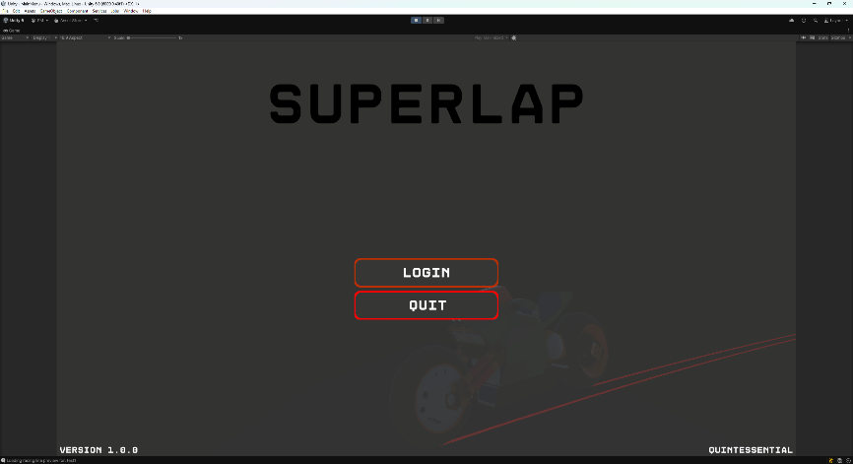**Login and Register**

**12**

**2**

**3**

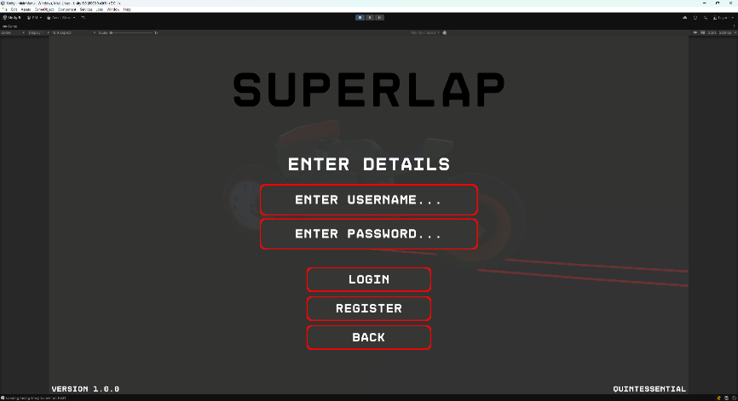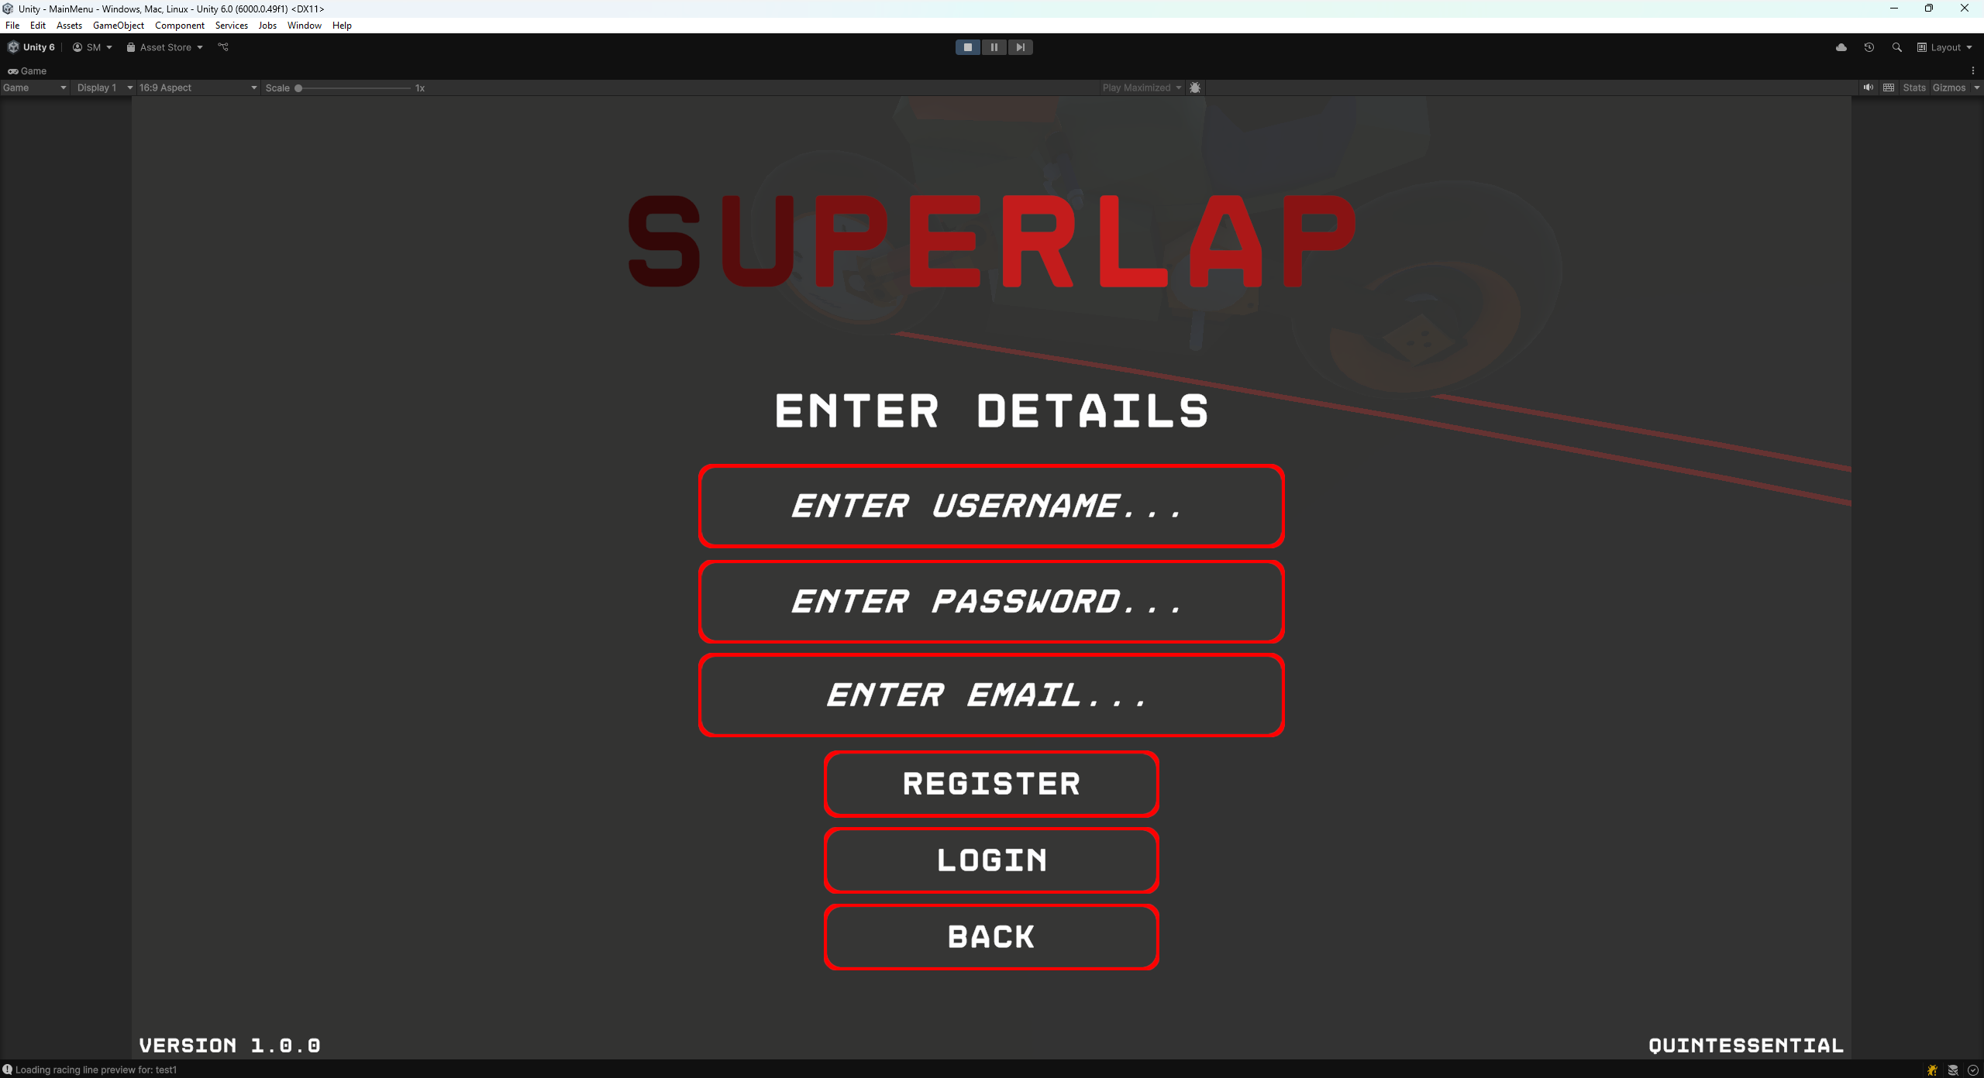

Once the system is installed and running, a user should select on “Login”. Here a user is able to enter their username and password to enter the system.

If a user has yet to sign up then they can select the “Register” button and sign up for the system. This includes registering their name, email and password.

They will then be directed to our “Dashboard” page.

1. **Upload a Track Image**

**22**

**32**

**12**

**42**

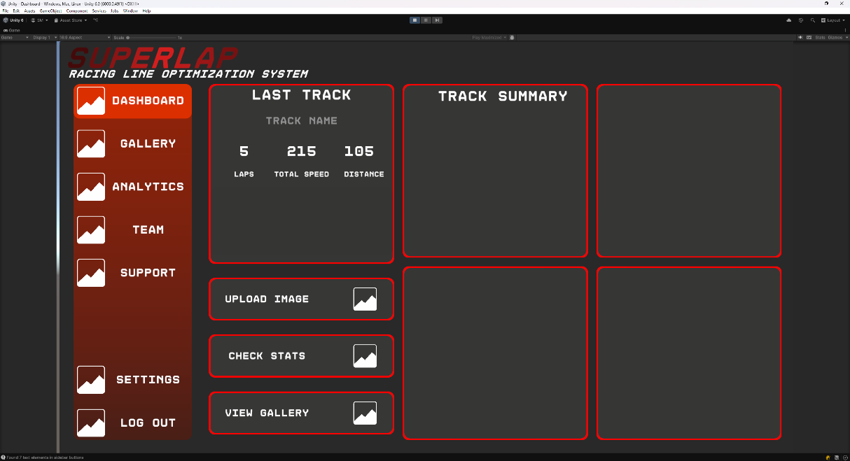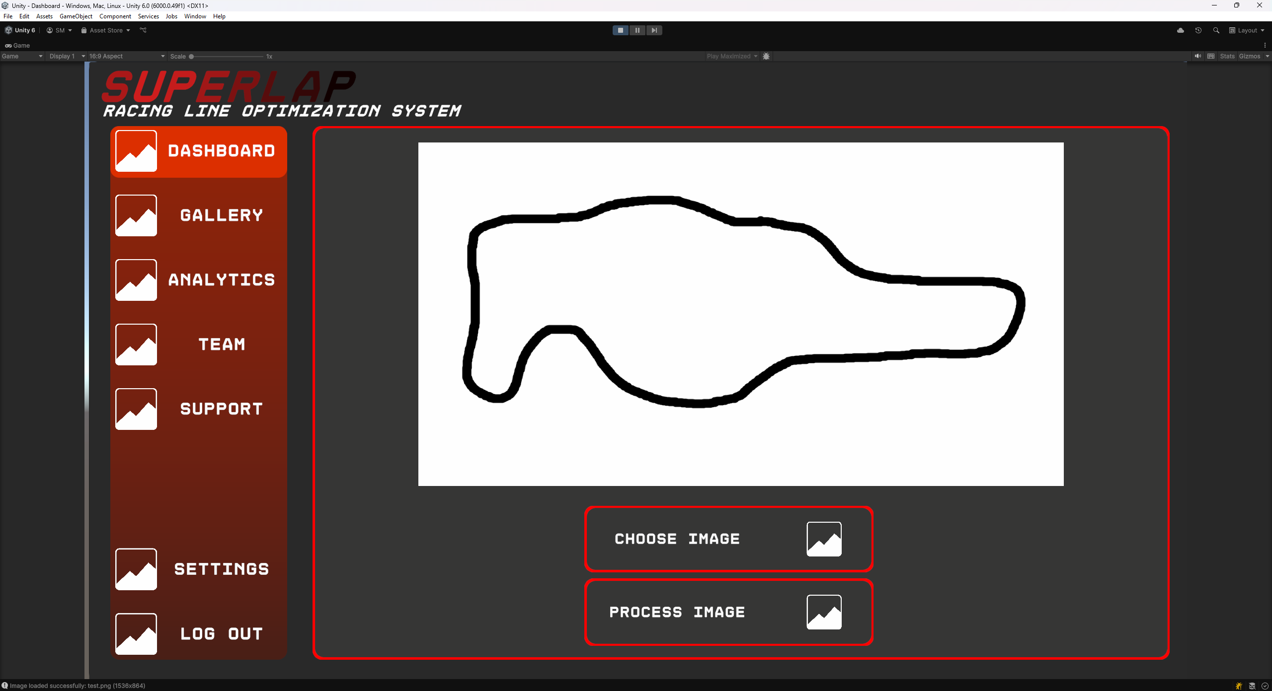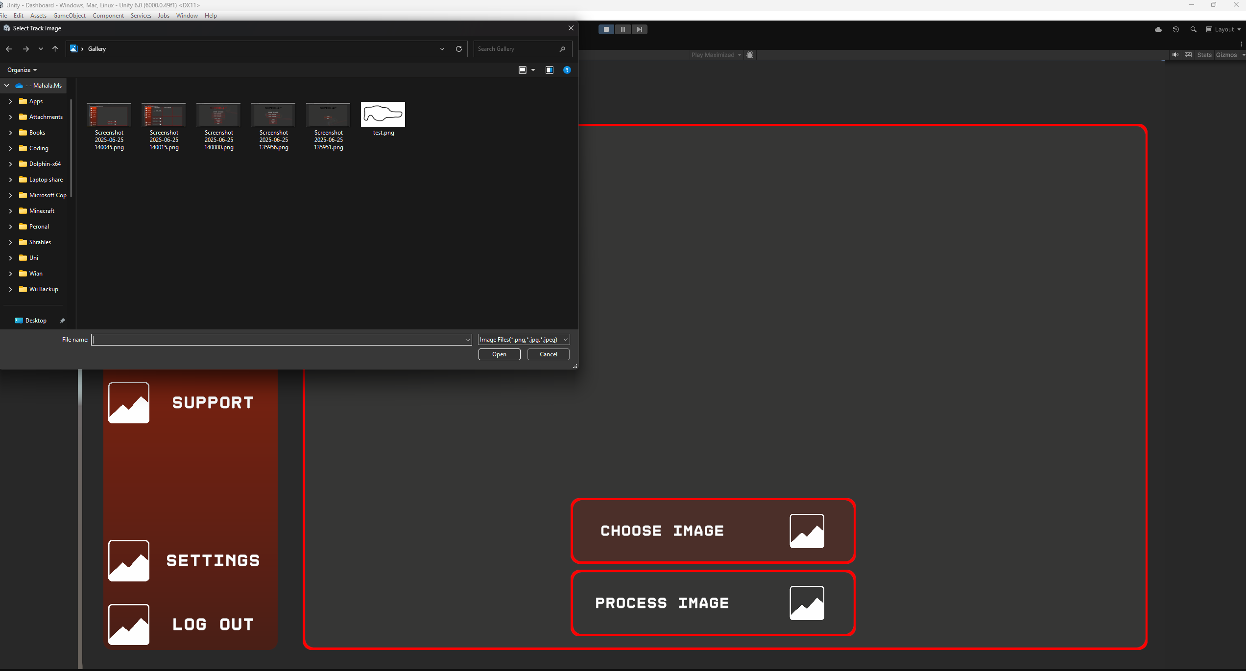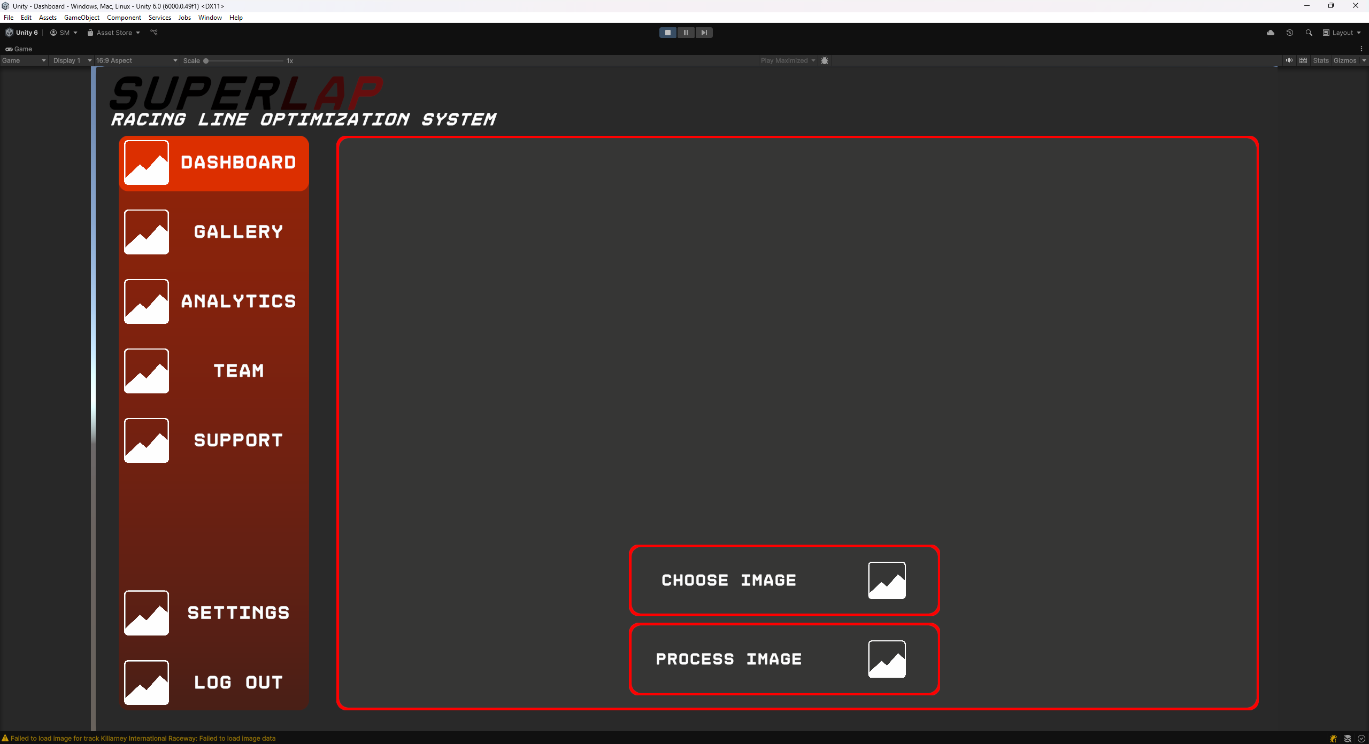

While on the “Dashboard” page a user is able to up load a track image from their device. Once an image has been selected, the user must select on “Choose Image” button.

1. **Processing a Track Image**

After an image has been selected, it is uploaded to the backend of the system. First the Image processor takes the image and calculate the outer and inner bounds of the track. These parameters are then passed into the Raceline Optimizer which uses a partial swarm algorithm to calculate the best track for that specific line.

1. 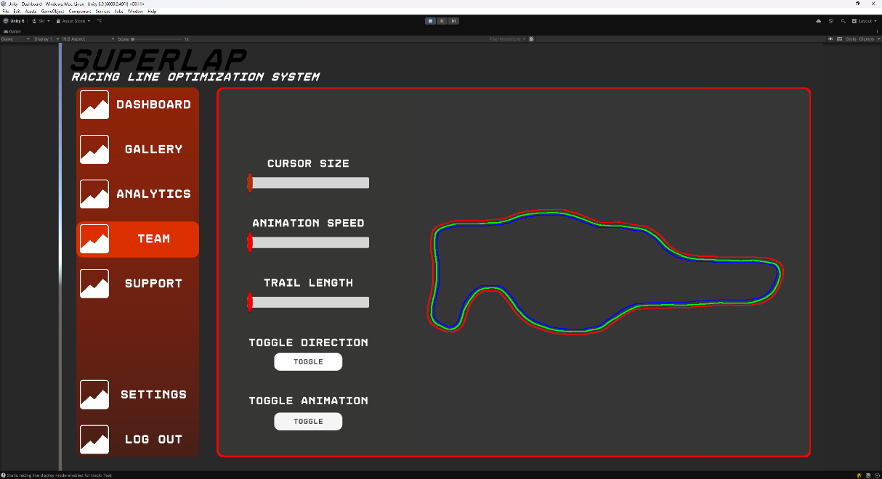**Viewing Results**

Once the system has analysed the track, it will display a track with red and blue line, the red line is the outer bounds of the track, while the blue is the inner bounds of the track. The green line, is the best path for the rider to follow around this specific track.

1. **A screenshot of a computer

   AI-generated content may be incorrect.Support Page (“Help Page”)**

This page has some common issues that some might run into when running our system. It also has an FAQ and contact link for interested users.

### Troubleshooting

* You cannot log into the system?
  + Ensure that it is running first.
* You can’t upload an image?
  + Ensure the system is still running and has not crashed.
* If Docker will not run try the following in the terminal (only run the next one, once the first is finished building):

docker-compose down --remove-orphans

docker-compose build --no-cache

docker-compose up

### Contact or Support Info

Please send any issues you may experience to our email at:

[ctprojectteam3@gmail.com](mailto:ctprojectteam3@gmail.com)

# Specifications and Standards

## Machine Learning Specification

[Needs to be created]

## API Documentation

[Needs to be created]

## Coding Standards

### Naming Conventions

**File Names:** A mix of PascalCase and camelCase is used.

**Folder Names:** Generally, use PascalCase. However, some folders follow lowercase naming conventions for system compatibility – for example, the docs folder is lowercase to enable GitHub Pages hosting.

**Class Names:** All class names follow PascalCase for clarity and consistency.

**Special Cases:**

* API and RacelineOptimizer follow PascalCase as they are core modules.
* image_processing uses snake_case to align with external library conventions and improve readability in multi-word module names.

### File and Folder Structure

The project is organized into modular folders to separate concerns and support scalable development. Below is the structure of the repository:

**Repository Root**

* Backend/ – Contains core backend components including:
  + API/: Handles external communication (e.g: Unity and MongoDB).
  + ImageProcessing/: Processes images received from Unity, converting them into usable track data.
  + RacelineOptimizer/: Uses processed images to determine the optimal raceline.
* docs/ – Stores documentation and static site files (used for GitHub Pages hosting). Subdirectories include:
* css/, js/, images/, wordDocs/, and index.html.
* scripts/ – Contains setup scripts and developer utilities:
  + setup-act.sh: Installs [nektos/act](https://github.com/nektos/act) to run GitHub Actions locally.
  + ACT.md: Documentation for using local workflows.
* Unity/ – The front-end Unity project used for rendering and interaction.
* Website/ – Web-related files for convenience and deployment purposes.
* README.md – Project overview and general instructions.

**Docker and Testing**

* Each service folder (except Unity) contains its own Dockerfile.
* A global docker-compose.yml file is located in the project root.
* .dockerignore files are placed in each relevant directory.
* Testing directories (e.g: tests_integration/, e2e/, unit/) are found within service folders for modular test execution.

### Formatting Standards

* **Indentation**: Tabs are used for indentation across the project for consistency.
* **Line Length**: No strict limit has been enforced, but lines are generally kept concise for readability.
* **Braces**: Opening braces are placed on the same line as control statements (e.g: if (...) {), with the block content starting on the next line.
* **Spacing**: Standard spacing is followed, including spacing around operators and within brackets (e.g: { int = 0; }).
* **Comments**:
  + Both single-line (//) and block (/* */) comments are used.
  + Single-line comments are used for short explanations, while block comments provide contextual or functional documentation.
* **Docstrings**: No specific docstring format is used in this project.

### Coding Practices

* **Naming**: Functions and files are named to clearly reflect their purpose or output. Descriptive naming is prioritized over name length limitations.
* **Structure**: Code is kept modular and functions are designed to handle specific tasks where possible.
* **General Practices**: Standard coding practices are followed, including avoiding deeply nested logic, keeping code readable, and minimizing redundancy.

### Version Control Guidelines

**Commit Messages**: All commit messages must be clear, descriptive, and explain what the commit does.

**Branching Strategy**:

The primary branches are:

* main: Stable production-ready code.
* dev: Integration branch for completed features.

Feature branches are categorized by function:

* UI/: Frontend and website-related work
* Backend/: Backend processing and API
* CICD/: Continuous Integration and Deployment scripts/tests

Branch naming follows a consistent format:

* Example: Backend-PSA-start, UI-Web-LandingPage

**Commit Frequency**: Developers are expected to make a minimum of 10 commits per week, ideally after every significant update on their feature branch.

**Pull Requests**:

* Pull requests must be submitted once a branch feature is complete.
* Each PR must be reviewed by **at least two team members** before being merged.
* Branches are merged progressively: feature → category (e.g: UI) → dev → main.
* Direct commits to main are not allowed.

**CI/CD**: The main branch runs the CI/CD pipelines to ensure stability.

### Tools and Configurations

**CI/CD**: A basic CI/CD setup is implemented, currently running automated tests from the various tests folders.

**Docker**:

* Each backend component (API, ImageProcessor, RacelineOptimizer) has its own Dockerfile.
* A root-level docker-compose.yml is used to orchestrate the containers.

**Scripts**: Utility scripts are stored in the scripts/ directory for local tool setup and CI/CD helpers.

**Linters/Formatters**: Not strictly enforced, but individual team members may use personal formatting tools suited to their language. There is also currently linting present in our C# code.

### Language/ Framework-Specific Conventions

**Unity and RacelineOptimizer:** Written in C#. Follows typical Unity/C# naming and structure conventions.

**API:** Implemented in Node.js using JavaScript/TypeScript.

**Image Processor:** Written in Python, using common Pythonic conventions (e.g: snake_case, modular scripts).

**Website:** Built with standard HTML, CSS, and JavaScript, organized within the docs/ folder for GitHub Pages compatibility.

## Testing Policy

### Testing Scope & Levels

|  |  |  |
| --- | --- | --- |
| Level | Focus | Tools/Methods |
| Unit Testing | Individual functions (e.g: track image processing, RL reward function). | Pytest (Python), JUnit (Java). |
| Integration Testing | Interaction between services (e.g: track processor → RL engine). | Postman, Jest (API tests), Selenium (UI flows). |
| System Testing | End-to-end workflows (e.g: upload image → simulate → visualize). | Cypress, Robot Framework. |
| Performance Testing | Scalability (e.g: 50 concurrent users), RL training speed. | Locust (load testing), NVIDIA Nsight (GPU profiling). |
| Security Testing | Data encryption, auth vulnerabilities. | OWASP ZAP, SonarQube. |
| User Acceptance (UAT) | Real-world usability (by target users). | Beta releases, A/B testing. |

### Testing Types & Frequency

|  |  |  |
| --- | --- | --- |
| Test Type | Description | Frequency |
| Automated Regression | Validate existing features after updates. | On every Git commit (CI/CD). |
| Manual Exploratory | Unscripted UX/edge-case testing. | Before major releases. |
| Physics Validation | Compare AI racing lines against known heuristics (e.g: apex accuracy). | Per RL model update. |

### Entry & Exit Criteria

**Entry Criteria (Tests Start When):**

* Requirements are documented.
* Code is merged to the test branch.
* Test environment mirrors production (GPU-enabled).

**Exit Criteria (Tests Pass When):**

* **Unit/Integration:** ≥90% code coverage (measured via Coveralls).
* **Performance:** <2s response time for track processing; RL training FPS ≥30.
* **Security:** Zero critical OWASP vulnerabilities.
* **UAT:** ≥80% positive feedback from beta testers.

#### Defect Management

* **Severity Levels:**
  + **Critical** (Crash/data loss): Fixed within 24h.
  + **Major** (Feature failure): Fixed in next sprint.
  + **Minor** (UI glitch): Backlogged for prioritization.
* **Tracking:** Jira/Linear with labels (bug, reproducible, blocker).

#### Environments

|  |  |  |
| --- | --- | --- |
| Environment | Purpose | Access |
| Development | Feature development. | Engineers only. |
| Staging | Pre-production (mirrors prod). | QA/Product Team. |
| Production | Live user-facing system. | Automated deployments only. |

#### Test Data Management

* **Realistic Datasets:**
  + 10+ sample tracks (F1, MotoGP circuits).
  + Synthetic data from racing sims (Assetto Corsa).
* **Anonymization:** User-uploaded tracks scrubbed of metadata.

#### Compliance & Reporting

* **Audits:** Monthly test coverage/review meetings.
* **Reports:** Dashboards for:
  + Test pass/fail rates.
  + Performance trends (e.g: lap time prediction accuracy).

#### Policy Exceptions

* **Emergency Fixes:** Hotfixes may bypass some tests but require:
  + Post-deployment regression testing.
  + Retrospective review.

# Contribution of Teammates

## Project Manager

### Amber Werner

* Documentation
* Diagrams
* Testing
* Create Landing Page

## Backend Developers

### Qwinton Knocklein

* Documentation
* Image Processor Development
* Testing

### Sean van der Merwe

* Documentation
* Race line Optimization (AI Development)
* Integration

## Front End Developers

### Simon van der Merwe

* Documentation
* DevOps
* Integration

### Milan Kruger

* Documentation
* Front End
* Intergradation

# Appendix: Old Versions of SRS

## Version 1 [26/05/2025]

**Introduction**

There is a growing need for accessible, data-driven training tools in motorsports, especially among students, amateur riders, and enthusiasts who lack access to expensive telemetry systems or real-world testing environments. SuperLap Racing Line Optimization System addresses this need by providing an AI-powered platform that helps superbike riders identify the fastest possible racing line on a racetrack.

The project aims to develop a Reinforcement Learning and Computer Vision-based system that analyses a top-down image of a racetrack, simulates thousands of optimal pathing scenarios, and overlays the ideal racing line on the map. Designed with usability and precision in mind, SuperLap focuses on delivering accurate, performance-enhancing insights in a visually intuitive format, supporting smarter race training without the traditional barriers of cost or access.

User Characteristics

Amateur & Hobbyist Racers

**Characteristics:**

* **Skill Level:** Novice to intermediate riders.
* **Goals:** Improve lap times, learn optimal racing lines, and understand track dynamics.
* **Technical Proficiency:** Basic (comfortable with apps but not deep technical knowledge).
* **Usage:**
  + Uploads track images from local circuits.
  + Uses AI-generated racing lines as training aids.
  + Compares different lines for self-improvement.
* **Motivation:** Cost-effective alternative to professional coaching/telemetry.

**Example:** A track-day rider at Kyalami Circuit who wants to shave seconds off their lap time.

Motorsport Coaches & Instructors

**Characteristics:**

* **Skill Level:** Advanced (former/current racers).
* **Goals:** Teach students optimal racing strategies using AI insights.
* **Technical Proficiency:** Moderate (understands racing physics but not AI/ML).
* **Usage:**
  + Validates AI suggestions against their experience.
  + Generates visual training materials for students.
  + Compares different rider lines for debriefs.
* **Motivation:** Enhances coaching efficiency with data-backed insights.

**Example:** A riding instructor at a racing school who uses SuperLap to show students braking points.

Sim Racing Enthusiasts

**Characteristics:**

* **Skill Level:** Varies (casual to competitive sim racers).
* **Goals:** Optimize virtual racing performance in games like *Assetto Corsa* or *Gran Turismo*.
* **Technical Proficiency:** High (comfortable with mods/data analysis).
* **Usage:**
  + Imports game track maps for AI analysis.
  + Compares SuperLap’s line against in-game telemetry.
  + Shares optimized lines with sim racing communities.
* **Motivation:** Gain a competitive edge in online races.

**Example:** An iRacing league player who wants the perfect Monza line.

Professional Racing Teams (Small/Privateer)

**Characteristics:**

* **Skill Level:** Expert (professional riders/engineers).
* **Goals:** Fine-tune bike setup and validate strategies.
* **Technical Proficiency:** High (understands AI, telemetry, and vehicle dynamics).
* **Usage:**
  + Cross-checks AI predictions with real-world data.
  + Tests "what-if" scenarios (e.g: wet vs. dry lines).
  + Integrates with existing telemetry tools (if API available).
* **Motivation:** Affordable alternative to high-end motorsport analytics.

**Example:** A privateer Moto3 team optimizing cornering lines on a budget.

Engineering & Motorsport Students

**Characteristics:**

* **Skill Level:** Academic (learning racing dynamics/AI).
* **Goals:** Study racing line theory, RL applications, and vehicle physics.
* **Technical Proficiency:** Medium (some coding/math knowledge).
* **Usage:**
  + Experiments with different AI models (e.g: DQN vs. PPO).
  + Validates academic theories against SuperLap’s simulations.
* **Motivation:** Research and project-based learning.

**Example:** A mechanical engineering student analysing Suzuka’s "S-curves" for a thesis.

User Stories

Core User Stories (Functionality & User Experience)

1. As a rider, I want to upload a top-down image of my racetrack so that the system can analyse it for racing line optimization.
2. As a user, I want to see and customize the image that I have uploaded.
3. As a user, I want to see the AI-generated optimal racing line overlaid on the track so that I can compare it to my existing racing strategy.
4. As a motorsport enthusiast, I want the system to simulate multiple racing lines using reinforcement learning so I can see which line performs the best under different conditions.
5. As a rider, I want to compare my recorded lap times with the AI’s optimal lap time so I can identify areas for improvement.
6. As a user, I want the app to visually simulate the lap with a bike animation in Unity so I can better understand the racing line’s logic.
7. As a beginner racer, I want simple guidance such as “brake here” or “turn in here” based on the AI's racing line, so I can apply it in real life.
8. As a user, I want to toggle between 2D and 3D views of the track to better analyse racing lines.

Visualization & Comparison Stories

1. As a racer, I want to switch between different racing line strategies (self-set vs. AI-optimized) so I can decide which one is best suited for my skill level.
2. As a user, I want the ability to scrub through a lap simulation to analyse key moments like braking zones and apex points.
3. As a coach, I want to export performance data and AI-generated lines for further analysis outside the app.

Interface & User Experience Stories

1. As a casual user, I want a guided tutorial on how to interpret AI racing lines and use the app effectively.
2. As a user, I want to switch between light and dark modes for better visibility depending on the time of day.

Backend & Performance Stories

1. As a backend developer, I want the system to efficiently process large track images to reduce wait time for the user.
2. As a power user, I want to configure AI training parameters (e.g: epsilon decay, learning rate) for custom experiments.
3. As a team, we want to store training sessions and model states securely in a database so that progress isn’t lost between runs.

Gamification & Community Stories

1. As a user, I want to share my best lap and AI-optimized strategy with others to compare and compete.
2. As a community member, I want to vote on or comment on AI racing lines that others have shared to collaborate and learn.
3. As a racer, I want leaderboards showing AI lap times vs. user lap times to motivate improvement.

Use Case

Service Contracts

Track Image Processing

|  |  |
| --- | --- |
| Aspect | Description |
| Service Name | Track Image Processing |
| Description | Allows users to upload a top-down image of a racetrack. The system processes and standardizes it for analysis. |
| Inputs | Image file (JPG/PNG), optional track name or location |
| Outputs | Normalized track layout data (internal format), confirmation message |
| Interaction | Frontend sends image via HTTP POST; backend responds with processed track data or error |

Racing Line Optimization

|  |  |
| --- | --- |
| Aspect | Description |
| Service Name | Racing Line Optimization |
| Description | Calculates optimal racing line based on uploaded track image and racing parameters |
| Inputs | Track layout data, user skill level (optional), simulation settings |
| Outputs | Optimal line data (coordinates + speed/brake points), estimated lap time |
| Interaction | Backend returns optimized racing line as data or overlaid image |

AI Training Service

|  |  |
| --- | --- |
| Aspect | Description |
| Service Name | AI Training Service |
| Description | Trains reinforcement learning models to simulate different racing strategies on the track |
| Inputs | Track layout, AI parameters (e.g: learning rate, episodes), training goals |
| Outputs | Trained model, performance logs, fastest simulated lap time |
| Interaction | Invoked from backend or developer interface; may take time (async) |

Visualization Service

| Aspect | Description |
| --- | --- |
| Service Name | Visualization of Results |
| Description | Visually simulates laps using 2D/3D track views and overlays AI data on the track |
| Inputs | Racing line data (AI and/or user), view preferences (2D/3D), playback controls |
| Outputs | Unity-powered animation/render, scrub controls, brake/acceleration cues |
| Interaction | Real-time interaction on frontend with data fetched from backend |

User Account Management (optional)

|  |  |
| --- | --- |
| Aspect | Description |
| Service Name | User Account Management |
| Description | Handles user registration, login, and preferences storage |
| Inputs | Email, password, user profile info |
| Outputs | Auth tokens, session info, user data |
| Interaction | API-based login/signup endpoints, token-based authentication for access to services |

Lap Time Comparison

|  |  |
| --- | --- |
| Aspect | Description |
| Service Name | Lap Time Comparison |
| Description | Compares user-recorded lap times against AI’s optimal laps |
| Inputs | User lap times (manually entered or uploaded), AI lap data |
| Outputs | Comparison report, performance delta, suggestions for improvement |
| Interaction | Web interface comparison, downloadable report or visual overlay |

**Requirements**

Technology Requirements

|  |  |  |
| --- | --- | --- |
| Technology | Purpose | Justification |
| Git & GitHub | Version control & collaboration | Enables efficient branching, tracking, and CI/CD workflows via GitHub Actions. |
| Python | AI/ML Model development | Widely adopted in ML with extensive libraries (e.g: PyTorch, NumPy). |
| PyTorch/TensorFlow | Reinforcement Learning (RL) framework | Industry-standard for RL; supports GPU acceleration for faster training. |
| OpenCV | Image processing & track detection | Effective for binary conversion and track boundary detection. |
| Matplotlib/Plotly | 2Ddata visualization | Ideal for overlaying racing lines on images for analysis. |
| Unity | 3D Visualization | Provides immersive simulations with real-time physics rendering. |
| React | Web interface | Modern, responsive frontend that integrates well with visualization libraries. |
| Express | Backend API service | Lightweight Node web framework for seamless model serving and data routing. |
| Docker | Containerization | Ensures reproducibility across environments (e.g: cloud, local). |
| SQLite/PostgreSQL | Database for storing track/line data | Lightweight (SQLite) or scalable (PostgreSQL) for performance logs. |
| PyBullet/MuJoCo | Physics engine (optional) | Simulates bike dynamics and tire friction for more accurate RL training. |

Functional Requirements

R1: Track Image Processing

R1.1: Image Conversion

* The system will convert top-down racetrack images into binary maps for AI analysis.
* The system will load data from saved csv files for comparison.

R1.2: Boundary Detection

* The system will accurately detect and distinguish track boundaries from off-track areas.
* The system will store this information for future use.

R2: Racing Line Optimization

R2.1: Reinforcement Learning

* The system will apply Reinforcement Learning (RL) to simulate and refine racing lines.
* The system will use data saved as .csv files to train the AI.

R2.2: Path Evaluation

* The system will iterate through multiple paths to determine the fastest racing line.

R3: AI Training and Simulation

R3.1: Training Data Input

* The system will train AI agents using simulated or game-based datasets.

R3.2: Physics Modelling

* The system will incorporate physics-based models to ensure realistic performance.

R4: Result Visualization

R4.1: Line Overlay

* The system will overlay the optimized racing line on the track image.
* The system will allow for adjustments to the overlay.

R4.2: Performance Metrics

* The system will display key performance indicators such as estimated lap time and braking zones.

R5: Infrastructure Integration

R5.1: Computation Support

* The system will support sufficient computational resources (e.g: GPU) for RL training.

R5.2: Cloud Compatibility

* The system will optionally integrate with cloud services to allow for scalability and extended computation.

R6: Adaptive AI Strategies

R6.1: Dynamic Track Conditions

* The system will adjust racing lines based on simulated track conditions (e.g: wet/dry surfaces).

R7: Enhanced Visualization & User Interaction

R7.1: Interactive 3D Simulation (Optional)

* The system will provide a 3D interactive visualization of the track and optimized racing line.

R7.2: Dynamic Line Adjustment

* The system will allow users to manually adjust the racing line and re-simulate performance with sliders and input areas.

R7.3: Heatmap of Speed/Acceleration Zones

* The system will generate a speed/acceleration ‘heatmap’ overlay for performance analysis.
* The system will allow users to provide feedback on AI-generated lines for iterative improvement.

Architectural Requirements

Quality Requirements

NF1: Performance Requirements

* **NF1.1:** The system will process and analyse a racetrack image (≤10MB) in under 5 seconds.
* **NF1.2:** AI training simulations will run at ≥30 FPS for real-time feedback during optimization.
* **NF1.3:** Lap time predictions will be computed within 1 second after track processing.
* **NF1.4:** The system will support at least 50 concurrent users in cloud-based mode.

NF2: Security Requirements

* **NF2.1:** All user-uploaded track images and telemetry data will be encrypted in transit (HTTPS/TLS 1.2+).
* **NF2.2:** Sensitive user data (e.g: login credentials) will be stored using salted hashing (bcrypt/PBKDF2).
* **NF2.3:** The system will enforce role-based access control (RBAC) for admin vs. end-user privileges.
* **NF2.4:** AI models and training data will be protected against unauthorized modification.

NF3: Reliability & Availability

* **NF3.1:** The system will maintain 95% uptime under normal operating conditions.
* **NF3.2:** Critical failures (e.g: RL training crashes) will recover automatically within 10 minutes.
* **NF3.3:** Backup procedures will ensure no more than 1 hour of data loss in case of system failure.
* **NF3.4:** The offline mode will retain core functionality (track processing, pre-trained AI suggestions) without cloud dependency.

NF4: Usability Requirements

* **NF4.1:** The interface will be intuitive for non-technical users (e.g: drag-and-drop track uploads, one-click simulations).
* **NF4.2:** Visualizations (racing line overlays, metrics) will adhere to colorblind-friendly palettes.
* **NF4.3:** The system will provide tooltips/guided tutorials for first-time users.
* **NF4.4:** All critical actions (e.g: deleting data) will require user confirmation.

NF5: Scalability Requirements

* **NF5.1:** The system will scale horizontally to support up to 10,000 simulations/day via cloud resources.
* **NF5.2:** Modular architecture will allow integration of new physics models or RL algorithms without major refactoring.
* **NF5.3:** GPU-accelerated training will dynamically allocate resources based on workload.

NF6: Compatibility Requirements

* **NF6.1:** The system will support Windows, macOS, and Linux for desktop applications.
* **NF6.2:** Web-based access will be compatible with Chrome, Firefox, and Edge (latest versions).
* **NF6.3:**Track images will be accepted in JPEG, PNG, or SVG formats (≤10MB).

NF7: Maintainability Requirements

* **NF7.1:** Code will be documented with API specs, inline comments, and version control (Git).
* **NF7.2:** The system will log errors with timestamps, severity levels, and recovery suggestions.
* **NF7.3:** Third-party dependencies (e.g: PyTorch, OpenCV) will be pinned to stable versions.

NF8: Cost & Resource Constraints

* **NF8.1:** Cloud computing costs will not exceed R5000 (aligned with project budget).
* **NF8.2:** Offline mode will operate on consumer-grade hardware (e.g: NVIDIA GTX 1060+ for GPU acceleration).

Architectural Pattern

Architectural Overview

The system will adopt a **microservices-based architecture** and **event driven architecture** to ensure modularity, scalability, and maintainability. Each major functionality – such as image preprocessing, reinforcement learning (RL) training, visualization, and user management – will be encapsulated within its own loosely coupled service. These services will communicate through event-driven mechanisms using technologies such as Kafka or RabbitMQ, enabling asynchronous processing and reactive behaviour across the platform.

This architectural approach is particularly suited to our application's workflow, where user actions (e.g: uploading a track or sharing a lap) trigger a cascade of processing stages. By decoupling components and promoting asynchronous event handling, the system remains scalable and resilient to failure in individual services.

Architectural Patterns

Event-Driven Architecture (EDA)

The system will heavily rely on Event-Driven Architecture to coordinate asynchronous tasks. When users upload new track images, an event will trigger the preprocessing pipeline. Similarly, once RL model training completes, another event will initiate the visualization service to generate optimal racing lines.

Examples of events include:

* TrackUploaded → triggers TriggerPreprocessing
* ModelTrainingCompleted → triggers GenerateOptimalLine
* UserSharesLap → triggers UpdateLeaderboard

This architecture allows components to remain decoupled and scale independently, improving performance and fault tolerance.

Model-View-Controller (MVC)

For user interaction and visualization, especially within Unity and potential web-based frontends, the system will follow the Model-View-Controller (MVC) design pattern:

* **Model**: Represents application data such as track metadata, AI model outputs, and simulation results (stored in MongoDB and PostgreSQL).
* **View**: Consists of Unity-based 3D visualizations and optional web dashboards built using React and Three.js.
* **Controller**: Handles user input, routes it to backend services, and updates the view with the appropriate state changes.

This separation of concerns simplifies UI development and makes the interface more responsive and maintainable.

Core Components and Interactions

The core system components and their interactions are described as follows:

* Track Processing Service
  + Input: Top-down track images (JPEG/PNG).
  + Output: Binary maps and detected boundaries, stored in Redis for fast retrieval.
  + Technology: Python, OpenCV.
* Reinforcement Learning (RL) Training Service
  + Input: Binary maps and physics parameters (e.g: tire grip, bike specs).
  + Output: Optimized racing lines with version control, stored in PostgreSQL.
  + Technology: PyTorch/TensorFlow, Python.
* Simulation Engine
  + Models realistic physics using a simulation library such as PyBullet or a custom engine.
* API Gateway
  + Offers REST and GraphQL endpoints for frontend access and internal coordination.
* Frontend
  + Web-based interface using React and Three.js, with optional desktop client via Electron.
  + Visual rendering through Unity.

**Data Flow Overview:**

User Upload → Track Processing → RL Training → Simulation → Visualization

Data Management

The system will employ a hybrid data storage strategy:

* Track images and metadata will be stored in AWS S3 (or equivalent blob storage) for cost-efficient scalability.
* Simulation results and racing lines will be stored in MongoDB (for structured queries).
* Training datasets ingested from games or simulators will use Parquet file format for optimized columnar storage and analytics.

Scalability and Performance

RL training will be horizontally scalable using Kubernetes, allowing auto-scaling across GPU-enabled nodes.

During periods of peak usage, image preprocessing workloads will be offloaded to AWS Lambda for efficient resource utilization.

The frontend will leverage CDN caching to serve static assets rapidly and reliably.

Fault Tolerance and Recovery

RL training processes will checkpoint progress every 15 minutes, ensuring minimal data loss in the event of failure.

A replica standby PostgreSQL instance will provide automatic database failover.

User uploads will automatically retry up to 3 times before surfacing an error to the user, increasing resilience to transient issues.

Security Architecture

The system will adopt a zero-trust security model, incorporating the following mechanisms:

* Authentication & Authorization: All API requests will be validated using JWT tokens.
* Network Isolation: Training workloads will run in isolated VPCs for enhanced security.
* Data Encryption:
  + At rest: AES-256 encryption for data in S3 and PostgreSQL.
  + In transit: All communication between services and users will be secured using HTTPS and mTLS.

Deployment and DevOps

The system’s infrastructure will be managed using Infrastructure-as-Code (IaC) tools such as Terraform and Ansible. A robust CI/CD pipeline will be implemented using GitHub Actions or Jenkins, enabling:

* Unit testing with PyTest and integration testing using Selenium.
* Automated rollback in case of deployment errors, triggered if failure rate exceeds 5% in canary deployments.

Design Patterns

Façade

The Façade pattern is used to provide a simplified interface to the complex subsystems within the application. This design allows clients (e.g., frontend components or external APIs) to interact with the system through a unified entry point, hiding the complexity of underlying operations such as track processing, AI training, and data visualization. It promotes loose coupling between components and enhances maintainability by centralizing control logic.

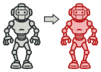Prototype

The Prototype pattern is employed to efficiently duplicate existing AI models, track configurations, or lap setups. This is particularly useful when users wish to reuse or slightly modify previously trained models or configurations without reprocessing them from scratch. Deep cloning ensures that replicated objects maintain their own state, avoiding unintended side effects caused by shared references.

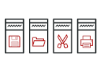Command

The Command pattern encapsulates user actions (such as uploading a track, modifying lap data, or initiating a simulation) as standalone command objects. This abstraction enables queuing, logging, and the ability to implement undo/redo functionalities. By decoupling the invoker from the execution logic, the system gains flexibility in handling user interactions in both the UI and backend workflows.

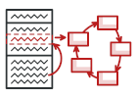State

The State pattern allows the system to alter its behaviour dynamically based on its current state. For example, the UI and backend processing logic behave differently depending on whether a track is being uploaded, a model is in training, or results are ready for visualization. This pattern ensures that transitions between states (e.g., Idle → Processing → Completed) are handled cleanly and predictably, improving the system's reliability and user experience.

Constraints

**Access to Real-World Telemetry:**

Obtaining authentic racing telemetry for supervised learning models may pose a challenge. As a result, alternative sources such as data from racing simulators or games may need to be utilized.

**Model Reliability and Accuracy:**

The outputs generated by the AI must be carefully compared against established racing techniques and strategies to ensure they are both accurate and dependable.

**Complexity in Image Analysis:**

The system must be capable of accurately processing track images, particularly in identifying circuit boundaries and optimal racing paths. Misinterpretations at this stage could compromise the entire prediction pipeline.

**Computational Resource Demands:**

Reinforcement learning processes are computationally intensive and require adequate hardware resources, such as GPUs or cloud-based solutions, to train effectively within a reasonable timeframe.

**Diagrams and Models**

Architecture Diagram

Class Diagram

Domain Model

Deployment Diagram

[Needs to be created]

**Manuals**

Installation Manual

[Needs to be created]

Technical Installation Manual

[Needs to be created]

User Manual

[Needs to be created]

**Specifications and Standards**

Machine Learning Specification

[Needs to be created]

API Documentation

[Needs to be created]

Coding Standards

[Needs to be created]

Testing Policy

Testing Scope & Levels

|  |  |  |
| --- | --- | --- |
| Level | Focus | Tools/Methods |
| Unit Testing | Individual functions (e.g: track image processing, RL reward function). | Pytest (Python), JUnit (Java). |
| Integration Testing | Interaction between services (e.g: track processor → RL engine). | Postman, Jest (API tests), Selenium (UI flows). |
| System Testing | End-to-end workflows (e.g: upload image → simulate → visualize). | Cypress, Robot Framework. |
| Performance Testing | Scalability (e.g: 50 concurrent users), RL training speed. | Locust (load testing), NVIDIA Nsight (GPU profiling). |
| Security Testing | Data encryption, auth vulnerabilities. | OWASP ZAP, SonarQube. |
| User Acceptance (UAT) | Real-world usability (by target users). | Beta releases, A/B testing. |

Testing Types & Frequency

|  |  |  |
| --- | --- | --- |
| Test Type | Description | Frequency |
| Automated Regression | Validate existing features after updates. | On every Git commit (CI/CD). |
| Manual Exploratory | Unscripted UX/edge-case testing. | Before major releases. |
| Physics Validation | Compare AI racing lines against known heuristics (e.g: apex accuracy). | Per RL model update. |

Entry & Exit Criteria

**Entry Criteria (Tests Start When):**

* Requirements are documented.
* Code is merged to the test branch.
* Test environment mirrors production (GPU-enabled).

**Exit Criteria (Tests Pass When):**

* **Unit/Integration:** ≥90% code coverage (measured via Coveralls).
* **Performance:** <2s response time for track processing; RL training FPS ≥30.
* **Security:** Zero critical OWASP vulnerabilities.
* **UAT:** ≥80% positive feedback from beta testers.

Defect Management

* **Severity Levels:**
  + **Critical** (Crash/data loss): Fixed within 24h.
  + **Major** (Feature failure): Fixed in next sprint.
  + **Minor** (UI glitch): Backlogged for prioritization.
* **Tracking:** Jira/Linear with labels (bug, reproducible, blocker).

Environments

|  |  |  |
| --- | --- | --- |
| Environment | Purpose | Access |
| Development | Feature development. | Engineers only. |
| Staging | Pre-production (mirrors prod). | QA/Product Team. |
| Production | Live user-facing system. | Automated deployments only. |

Test Data Management

* **Realistic Datasets:**
  + 10+ sample tracks (F1, MotoGP circuits).
  + Synthetic data from racing sims (Assetto Corsa).
* **Anonymization:** User-uploaded tracks scrubbed of metadata.

Compliance & Reporting

* **Audits:** Monthly test coverage/review meetings.
* **Reports:** Dashboards for:
  + Test pass/fail rates.
  + Performance trends (e.g: lap time prediction accuracy).

Policy Exceptions

* **Emergency Fixes:** Hotfixes may bypass some tests but require:
  + Post-deployment regression testing.
  + Retrospective review.

**Contribution of Teammates**

Project Manager

Amber Werner

[list contributions]

Backend Developers

Qwinton Knocklein

[list contributions]

Sean van der Merwe

[list contributions]

Front End Developers

Simon van der Merwe

[list contributions]

Milan Kruger

[list contributions]

## Version 2 [26/05/2025]

**Current Document.**